|  |  |  |
| --- | --- | --- |
| **05-863/08-763/46-863: Introduction to Human Computer Interaction for Technology Executives**  **Heuristic Evaluation Report Template**  **Dated**  **10/23/2017**   |  | | --- | | **Prepared By:**  **YOUR NAME:**  **SIGNATURE :** |  |  | | --- | | **Evaluation Of:**  **Name of system being evaluated (if any):** UPMC pharmacy website  **Person who created the system being evaluated:** N/A | |

|  |  |
| --- | --- |
| **Feedback & Critical Incidence** | << Record your observations in the table on the following page, based on your observations and notes taken during the user test  Description of columns in the table are as follows:  *Prototype Screen/Page:*  Which screen of the user interface was being tested at the point of feedback/critical incidence/problem.  *Name of Heuristic:*  Which of the 10 heuristics is being referenced. Enter the full name of the heuristic. Here is a list: <http://www.nngroup.com/articles/ten-usability-heuristics/>  *Reason for negative feedback / breakdown:*  Explain the reasons why the interface violates or upholds this heuristic. Be sure to be clear about *where* in the screen you are referencing.  *Scope:*  Describe the scope of the feedback or the problem; include whether the scope of the issue is throughout the product or within a specific screen or screens. If the problems are specific to a page, include the appropriate page numbers.  *Severity (H/M/L) :*  Your assessment as to whether the implication of the feedback is *low*, *medium*, or *high* severity, and a justification for why you are giving it that rating.    *Way(s) to rectify and Tradeoffs (i.e., why the fix might not work):*  Suggestion for the modifications that might be made to the user interface to address the issue or issues in this row. You MUST include trade-offs to be credible. If you can’t think of some bad trade-off, say so.  *Action taken and Justification:*  DO NOT FILL IN THIS COLUMN. This will be filled in by the person who created the system being evaluated, to say what he did with respect to the recommendations you make. |

|  |  |  |  |  |  |  |  |
| --- | --- | --- | --- | --- | --- | --- | --- |
| **#** | **Prototype Screen** | **Name of Heuristic** | **Reason for negative feedback / breakdown** | **Scope** | **Severity**  (High/ Medium/ Low) and **Justification** for giving it that rating | **Way(s) to rectify and any Tradeoffs** (i.e., why the fix might not work) | **Action taken and Justification (*to by filled in later by the person who created the system being evaluated*)** |
| 1 | See Picture 1 | Error prevention | **No confirmation when creating password:** it is error prone for users to create passwords with typos or mistakes and submit it recklessly | Register page. | Rating: High – preventing error. Rationale: Since the password text field is visible, the likelihood of making mistake decreases. But visible password text fields may lead to a sense of insecurity. | Add another text field for password confirmation; better hide the passwords when users create them. Tradeoff: This adds to one more thing that users have to do and it might cause annoyance. | Add a text field for password confirmation. |
| 2 | See Picture 2 | Error Prevention | **Empty Cart is a redundant and error prone function:** it is barely used. Moreover, it’s easy to click on it by accident and delete everything in the cart. | Every page | Rating: High – preventing error. Rationale: There’s no occasion that users need to clear the carts by one click especially without checking what’s in the cart. | Remove the function or move the function to cart page. Tradeoff: There might be cases that users want to clear carts by one click, but to my knowledge, it is rare. | Empty Cart removed. |
| 3 | See Picture 3 | Visibility of System Status | **The multiple-dimension display of some medicine(Tylenol) is** **unnecessary****:** Page loading time is prolonged due to the dynamic effect. | Tylenol page | Rating: Medium –**Minimalist design**. Rationale: The multi-dimensional pictures result in delay of page loading. | Give loading reminders when loading pictures; use informative and meaningful pictures. Tradeoff: it may lead to inconsistency somewhere unknown. | We think pictures of multiple dimensions can help the consumer to know details of this product. Thus, we chose to keep the multiple-dimension display. |
| 4 | See Picture 4 | Aesthetic and minimalist design | **The font, color and place of page title is awkward:** the title of page and background pictures blend in. | Every page | Rating: Low –**Aesthetic design**. Rationale: The title of page is weird, but unlikely to cause | Remove the title of page to the blank below background pictures. Tradeoff: it may lead to inconsistency somewhere unknown. | Change the title to dark purple to make it match the main color of the theme. |
| 5 | See Picture 5 | Aesthetic and minimalist design | The font and color of search symbol is a little hard to identify at first sight | Every page except for index | Rating: Low –**Aesthetic design**. Rationale: The multi-dimensional pictures result in delay of page loading. | Fix the search logo and make it consistent in every page. Tradeoff: it may lead to inconsistency somewhere unknown. | Unify all the search icon. |
| 6 | See Picture 6 | Consistency and standards | The heading indicates that current page is “home” while it is not. | Every page except for index | Rating: Low –**Consistency and standards**. Rationale: It can be confusing, but unlikely to influence critical functions. | Fix heading and make it consistent to every page title. Tradeoff: it may lead to inconsistency somewhere unknown. | Make Home buttons inactive. |
| 7 | See Picture 7 | Consistency and standards | **Cart information is inconsistent on the same page:**  The small cart symbol on top right corner shows $0 while there are products in the shopping carts. | Shopping cart page | Rating: Low –**Consistency and standards**.  Rationale: It may cause confusion when users check on carts, but unlikely to influence critical functions. | Fix the amount in cart page. Tradeoff: it may lead to inconsistency somewhere unknown. | The cart page is prepared. |
| 8 | See Picture 8 | Consistency and standards | **Inconsistent placement of “Add to Cart” buttons:** The “Add to Cart” button is not in alignment for some products | Product page &  Product-all page | Rating: Low –**Consistency and standards**.  Rationale: It’s unlikely users cannot find button or make mistakes. | Fix the alignment. Tradeoff: it may lead to inconsistency somewhere unknown. | Fixed. Aligned all price tags and “Add to cart” buttons |
| 9 | See Picture 9 | Consistency and standards | **The drop-down selection for quantity in carts is confusing:** Choices range from 1 to +6, and “+6” is confusing | Cart page | Rating: Medium –**Consistency and standards**.  Rationale: the options are limited and “+6” is confusing. | Make the options consistent and increase the upper limits.  Tradeoff: it may lead to inconsistency somewhere unknown. | Fixed. Options range from 1 to 10. |
| 10 | See Picture 10 | Visibility of System Status | **The heart button is confusing:** The button next to almost every “Add to Cart” button doesn’t do anything. | Product page | Rating: Low –**visibility of system status**. Rationale: It can be removed if the button does nothing at all, or it will cause confusion. | Remove the button or give feedbacks for heart button.  Tradeoff: This may result in an inconsistency with something else, but unknown what that might be. | Fixed. To avoid confusion, all heart buttons are deleted. |
| 11 | See Picture 11 | Inconsistency | In the homepage, the “add to cart” button is presented as a logo but in the searching result and product category pages they are in the form of a button with words on it. And in the product page, there are two more kinds of this type of button. | Every product page | Rating: Low – Minor, cosmetic problem. Rationale: The kind of inconsistency will not cause users’ failure in finding the button. | Uniform the “add to cart” button in every page. Tradeoffs: may need to change the surrounding web components to adjust to the change of “add to cart button”. | The cart icon in homepage is not a button for “add to cart”. To avoid confusion, all the cart icons in homepage are deleted. In product page, all buttons are changed to the same. |
| 12 | See Picture 12 | Inconsistency | In the search result page, the last row of “add to cart” buttons are not placed in the same line. | Search result page | Rating: Low – Minor, cosmetic problem. Rationale: This inconsistency will not hinder the functionality of the button. | Try to change the layout, so that buttons in the same row can be placed in the same horizontal line. Tradeoffs: some changes of the layout may affect the layout of other components. | Fixed. |
| 13 | See Picture 13 | Inconsistency | The shopping cart page is clearly much narrower than other pages and it is too small and the words are small as well. | Shopping cart page | Rating: Low – Minor, cosmetic problem. Rationale: This inconsistency will not hinder the functionality but it is a little bit strange. | Increase the width of shopping cart page. Tradeoffs: this page may use different template of style from other pages. So it may be hard to change this and make it similar to other pages. | Font and buttons are bigger. The cart page is of the right size - Supposed to be narrow. |
| 14 | See Picture 14 | inconsistency | In the check-out page, there are three different kind of red buttons. | Check-out page | Rating: Low – Minor, cosmetic problem. Rationale: Customers will not fail to find the button due to this inconsistency. | Change the style of buttons in the check-out page and may choose one of them to set as the standard one. Tradeoffs: unknown. | Buttons’ color has been changed with different contrasts to direct the user into the right direction. Confirm page has the standard color. The other are different because they are optional. |
| 15 | See Picture 15 | Match between system and the real world | In the bottom of order confirmation page, there are three pictures representing for “other offers and discount” and will direct user to the homepage. But it is hard to tell what that three pictures mean without clear guidance. In the real world, this is not the common way of indicating the link to home page. | Check-out page | Rating: Medium problem. Rationale: Users can still find our links back to the homepage but it is not likely that they will find out this one. | Add instruction to indicate these pictures are entrance to the homepage. Tradeoffs: maybe links to other pages is more important and meaningful. | Added a mouse over-text when the user hovers over these product icons. Directs the user to an “Under Construction” page. |
| 16 | See Picture 16 | Match between system and the real world | In the shopping cart page, there is “TOTAL CART: $20.98”. This expression is rather strange. | Shopping cart page | Rating: Low – Minor, cosmetic problem. Rationale: Customers can still understand the meaning. | Change this phrase into “Item subtotal” or other words that are popularly used in the real world. Tradeoffs: unknown. | Fixed. Changed to “Total: $20.98”. |
| 17 | See Picture 17 | Error prevention | After clicking the final pay button, a prompt is shown to ask for double check. This feature is good for error prevention | Check-out page | Rating: High  Rationale: this feature is rather important and it is very thoughtful of them to consider this. | No need to change.  Tradeoff: ask for users’ double check. A little bit more work requires from the user. | Positive feedback. No need for changes. |
| 18 | See Picture 18 | Recognition rather than recall | After registration, we will be directed to the home page and will be automatically recognized as sign-in status. | Homepage | Rating: Medium  Rationale: this feature is very convenient because it does not ask for users to repeat the work of sign in which requires a lot of memory load. | No need to change.  Tradeoff: unknown. | Positive feedback. No need for changes. |
| 19 | See Picture 19 | Visibility of system status | Every change of the system status is obvious and easy to notice. | Every page. | Rating: High  Rationale: this feature is critical cause the web should always keep the user informed of what is going on. | No need to change.  Tradeoff: unknown. | Positive feedback. No need for changes. |
| 20 | See Picture 20 | Help and documentation | The document given by the developers is clearly written and lists all the functionality and non-implemented functionality. | Every page. | Rating: Medium  Rationale: documentation is important especially when the web is only a prototype. | No need to change.  Tradeoff: unknown. | Positive feedback. No need for changes. |
| 21 | See Picture 21 | Match between system and the real world | **No “sign out”**  There’s no sign out option after signed in.  (When clicking the “welcome back” after logged in, it jumps to log-in page again.) | All the pages  (header) | Rating: High.  Rationale: Sign out option is necessary for the users. | Add “sign out” link to the header beside “welcome back”. / Show a list with “sign out” option when hover the mouse over “welcome back”.  Tradeoff: N/A | Sign out is added for all the logged pages. |
| 22 | See Picture 22 | Flexibility and efficiency of use | **No “continue shopping” in the payment confirmation page.**  The user might want to continue shopping after payment. It’s less obvious to click things in the menu (like “home”) to keep shopping than clicking “continue shopping” directly. The “continue shopping” button might also induce the user to keep shopping. | Payment confirmation page | Rating: Low.  Rationale: Without “continue shopping” button, the user can still click “home” to keep shopping. But it’s better to add an obvious button like most websites. | Add a “continue shopping” button in the payment confirmation page.  Tradeoff: N/A | Added. |
| 23 | See Picture 23 | Match between system and the real world | **Jump to cart page when clicking “add to cart”**  Most online shopping websites stay at the product detail page or pop up a window after clicking “add to cart”. | Product detail page | Rating: Low.  Rationale: It might be more user friendly to stay at the product detail page or pop up a window after clicking “add to cart”. | Pop up a window to confirm the add-to-cart operation after clicking “add to cart”.  Tradeoff: If the user wants to go to the cart directly after added the item to cart, one more operation will be needed. | We think it is not a problem to jump to the cart page when clicking the “add to cart” button. Also, there is “continue shopping” button on the cart page. |
| 24 | See Picture 24 | Recognition rather than recall | **“Update cart”**  This requires the user to recall if an edit operation was made and update the cart manually if something was edited. The cart should automatically update if anything is edited instead. | Shopping cart page | Rating: High.  Rationale: The user can easily forget to update the cart after editing. And if this happens, the user must go back to edit again, which is very inconvenient. | Remove the “update cart” button and let the cart update automatically if anything is edited on the webpage.  Tradeoff: N/A | No change. The button is a mechanism to avoid accidental changes. It is intended to recalculate the total price - It helps the user in noticing changes that he made. |
| 25 | See Picture 25 | Recognition rather than recall | **“Shop by category” is dispersed and hard to find**  “Shop by category” is split into different pages. And one of its pages – “Cough, Cold and Flu Medications  ” is under “menu” >> “medicines” >> “essentials” >> “Cough, Cold & Flu”, which is very deep and hard to find. | All the pages  (header) | Rating: Medium.  Rationale: The “Shop by category” is deep and hard to find. So, the user need to memorize its position. | Merge all the main categories into one page and add a direct link in the top menu (like “Category”). When the mouse hover over “Category”, it can show the detailed categories.  Tradeoff: N/A | We will keep our format at this point, since most e-commerce websites use the same layout we used. We will see how real world users’ opinions to make final decision. |
| 26 | See Picture 26 | Match between system and the real world | **No score in review**  There’s no score option in reviewing the product. | Product detail  page | Rating: Medium.  Rationale: Most online shopping websites provide the option for the users to score the product in review. A score can be more intuitive than text comments. | Add a score in each user comment and add an average score in the product detail page.  Tradeoff: The user need to score the item in review. | Added stars to show the score in a more vivid way. |
| 27 | See Picture 27 | Match between system and the real world | **No “confirm password”**  There’s no “confirm password” text field in the register page. | Register page | Rating: Medium.  Rationale: Most websites require the user to confirm the password after they typed the new password.  Otherwise, the user might fail to log-in because of the typing mistakes in register. | Add a “confirm password” text field in the register page.  Tradeoff: The user need to type the password a second time. | Added Password Confirmation text field. |
| 28 | See Picture 28 | Match between system and the real world | “Weekly event” is confusing  This area shows discounted or new items. “Weekly event” is not the most accurate description. | Homepage | Rating: Low.  Rationale: As the title for the discounted products area, “weekly event” is a bit confusing. | Change “weekly event” into “on sale” or some more precise description.  Tradeoff: N/A | Event is a common terminology in retail. This means “on sale”, but also other special offers as well. Since we have discounted items and new items in this container, we had better keep “Weekly Event” rather than “on sale”. |
| 29 | See Picture 29 | Error prevention | **“Empty cart” is error-prone**  The “empty cart” is so close to the cart icon that the user might easily click it by error. | All the pages (header) | Rating: Low.  Rationale: This is a design detail that might lead to extra errors. | Remove the “empty cart” / move it further from the cart icon  Tradeoff: no “empty cart” option / still might empty the cart by error | Empty cart removed. |
| 30 | See Picture 30 | Consistency and standards | **Inconsistent in checkout page**  The layout of the checkout page for “log-in” and “as a guest” is different. | Checkout page for “log-in” and “as a guest” | Rating: Low.  Rationale: The design of checkout process should be consistent. | Unify the layout of these two pages.  Tradeoff: N/A | The layouts only differ in a few areas. They are purposefully different. The log-in page doesn’t ask for shipping/card details because the user would have already provided those details. |
| 31 | See Picture 31 | Flexibility and Efficiency of use | The picture next to “Pharmacy” is not presented in the Home page, and the “UPMC” and “pharmacy” are on different lines, which influences the interaction efficiency for the users. | index.html | Rating: Medium   * Cosmetic problem.   Rationale: The is no function related issue for the missing picture, but it’s on the Home page which the missing picture showed obvious to the customers. | May need to add the suitable picture correctly, or just move out the picture from the home page since it may unnecessary. Tradeoff: none. | The problem might be caused by the browser the classmate used. We will keep track the logo in following testing. |
| 32 | See Picture 32 | Visibility of system status &  Flexibility and Efficiency of use | The HOME label is always in black color, not only by clicking the “HOME” button, but also in other button. Customers may get confused by the inform information. | index.html | Rating: Medium  Rationale: The button colors plays a notification role for customers in navigating categories. The color for HOME always presented in black(current viewing page) may cause confusion for customers. | Need to modify the color for HOME from black to white when customers clicks to other labels. Tradeoff: none. | Inactivate the “Home” button. |
| 33 | See Picture 33 | Consistency and standards | The background color for weekly events is red, but the header and theme is purple, the color is not achieved the visual consistency. | index.html | Rating: Medium   * Cosmetic problem   The color consistency for theme color and the | The designers may want to change the color of weekly event to purple. Tradeoff: none. | Change the color of weekly event to match the header. |
| 34 | See Picture 34 | Consistency and standards | Inconsistency of the footer and the header. The footer color is in red, but the header color is in purple, the theme color for the website is not consistent. | index.html  register.html  index_login.html…(all the pages) | Rating: Medium  – The color Rational: consistency in header and footer is kind of important. | The designers should unify the theme color for both header and footer in all the pages to make the visual consistency for customers. Tradeoff: none. | Change footer to match header. |
| 35 | See Picture 35 | Flexibility and efficiency of use | The upper bound of adding quantity is 6, and the customers can’t add product to be more than 6 | cart.html | Rating: High  Rational: The adding number of products in the shopping cart should be more flexible to customers | The designers may want to add a side bar of “+” and “-” next to the quantity bars to help customers to modify the shopping product quantities. Tradeoff: none. | Maximum quantity increased to 10. No other addition. Drop-down list is more foolproof when compared to ‘+/-’. |
| 36 | See Picture 36 | Match between system and the real world | The delete button shown on the product picture, which is not in a logical order. | cart.html | Rating: Medium  Rationale: For customer’s convenient, the delete button should be presented in the following of the quantity amount. | The designers can add the delete button after the quantity, which is more reasonable for customers to modify the amount. | The icon has been moved to the right of the float. it has more space and different color so the user can notice it. |
| 37 | See Picture 37 | User control and freedom | There is no “back” button showed in the checkout page to allow customers to get back to the product page. | checkout.html | Rating: High  Rational: the “back” button is important for customers who would like to continue shopping | Add a “back” button in the top of the | Added. |
| 38 | See Picture 38 | Match between system and the real world | To follow the logical order, the left side of “Don’t have an account” should be in the “Click here to log in” | checkout.html | Rating: Medium  Rational: To follow the logic order and for better layout design | To move the Register button under the log in | Invalid. If it’s put in the drop-down section, the user can never see it in the first place. He would never go to a login forum expecting to find a sign-up section. |
| 39 | See Picture 39 | Match between system and the real world | Since there are listed all the filled in shipping information, the notification was showed as “Ship to a different address?” is kind of confused. | checkout.html | Rating: Medium  Rational: Usually we see a option button showed s “Shipping to the same address” | Changed “Ship to a different address?” to “Shipping to the same address” | N/A  Because the website has already the address of the user, the right form is essentially if the user prefers to ship the item to a different address. |
| 40 | See Picture 40 | User control and freedom | There is no “Back” button showed in the payment page if the customers want to change the payment method. | payment.html | Rating: High  Rational: the “back” button is important for customers who would like to switch to another payment method | Add a “Back” button in the top area of the payment page.  Tradeoff: None. | A Link has been added at the bottom of the payment method. |
| 41 | See Picture 41 | Match between system and the real world | “Weekly Event” doesn’t tell users what this division of content is about and what is weekly event. | homepage. | Rating: Low  Rationale: Not a proper usage of words | Change the wording. | There are “New” and “30% off” tag for products. |
| 42 | See Picture 42 | Consistency and standards | After log-in and click homepage again, the system will automatically log out. | Whole website | Rating: High  Rationale: This bug will encourage user to log in repeatedly until he or she gives up. | Apply log-in onto website-wise. | Prepare duplicate for all the pages as a after-login version. |
| 43 | See Picture 43 | Consistency and standards | Inconsistency between the navbar cart and checkout page cart.  Also clicking “update cart” doesn’t work. | Checkout page | Rating: High.  Rationale: This bug will make users confused about how much money they will spend on this website and make them feel unsafe. | Using databinding feature in some JavaScript framework to make two carts consistent. Remove “update cart” will make it clearer. | The nav bar has been fixed. However, functional buttons are optional |
| 44 | See Picture 44 | Error prevention | This table doesn’t prevent user from entering wrong information | Register page | Rating: Low.  Rationale: Error prevention will help user a lot when inputting their information. However, it’s optional. | Add email validation | Add password validation. |
| 45 | See Picture 45 | Aesthetic and minimalist design | The dialogue includes irrelevant information | Confirmation page | Rating: Low.  Rationale: Useless information won’t attract customers to read it. | Remove redundant information such as “You will find details …” | It’s very terse. That information is necessary to give the user the complete information about his status, what to expect, and what he will find on this page. |
| 46 | See Picture 46 | Consistency and standards | The products result page doesn’t match the search word. | Search result page | Rating: High.  Rationale: search result accuracy will have large impact on user’s decision of buying things on this website. | Change search engine or make result page more intuitive to read. | It is indicated in the Readme file that the default search result page is for “vitamin c” no matter what search word in the text field. |
| 47 | See Picture 47 | Consistency and standards | Clicking email doesn’t go to sending email page. Also it duplicates with contact us footer. | Website | Rating: Medium.  Rationale: The email box icon is confusing and encouraging users to do operations that this icon is not for. | Remove the mailbox icon. | It is indicated in the Readme file that the email link is not working. |
| 48 | See Picture 48 | Aesthetic and minimalist design | The nav bar is not in a row and it’s not pretty. | Website | Rating: Medium.  Rationale: It can have large impact on users’ decision of continuing browsing. | Beautify it. | This feedback is this classmate’s own preference. We will keep our style at this point. |
| 49 | See Picture 49 | Help and documentation | The change button doesn’t work | Checkout page | Rating: Medium.  Rationale: It doesn’t make sense to not let users to change their address. | Make it work | N/A  It is a static website. Functional buttons are optional. |
| 50 | See Picture 50 | Help users recognize, diagnose, and recover from errors | The “Under construction” icon is too big and too ugly. | Most category pages | High | Change it to some cute pictures that indicate same idea. | This feedback is this classmate’s own preference. We will keep our style at this point. |

Picture 1:

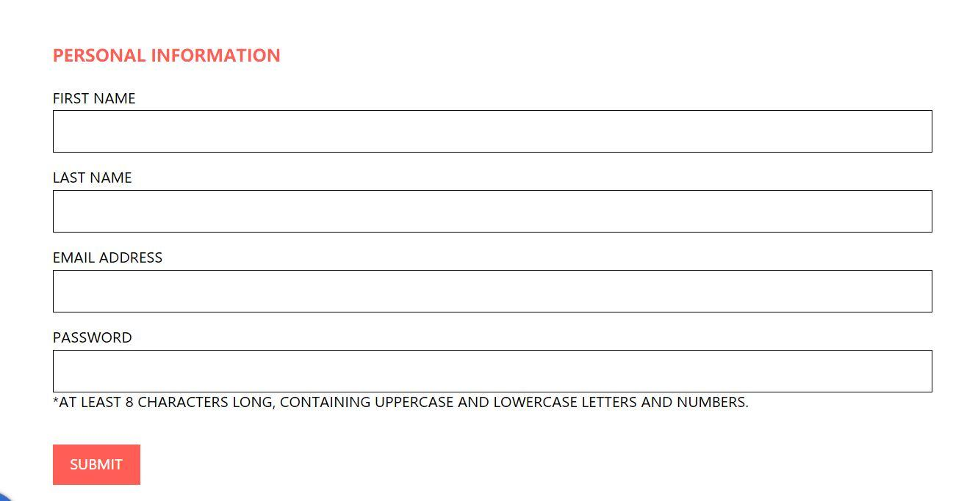

Picture 2:

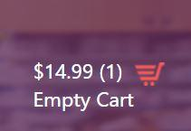

Picture 3:

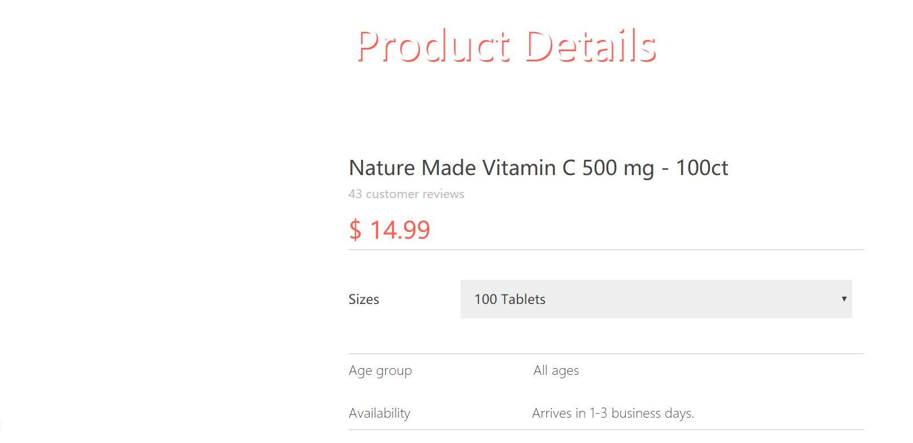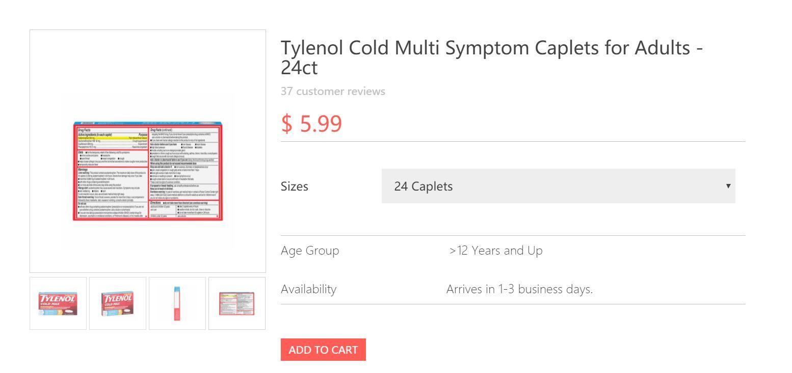

Picture 4:



<< insert picture 4 here >>

Picture 5:



Picture 6:

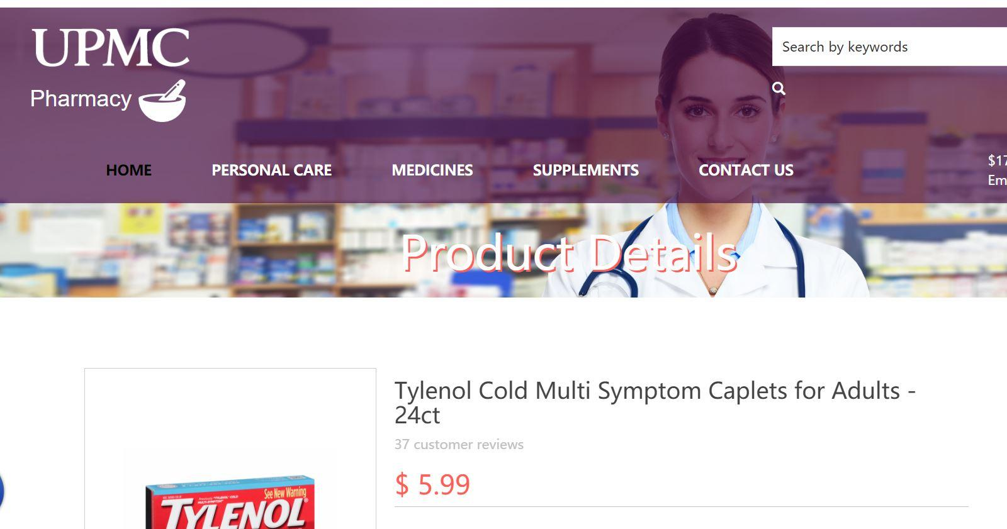

Picture 7:

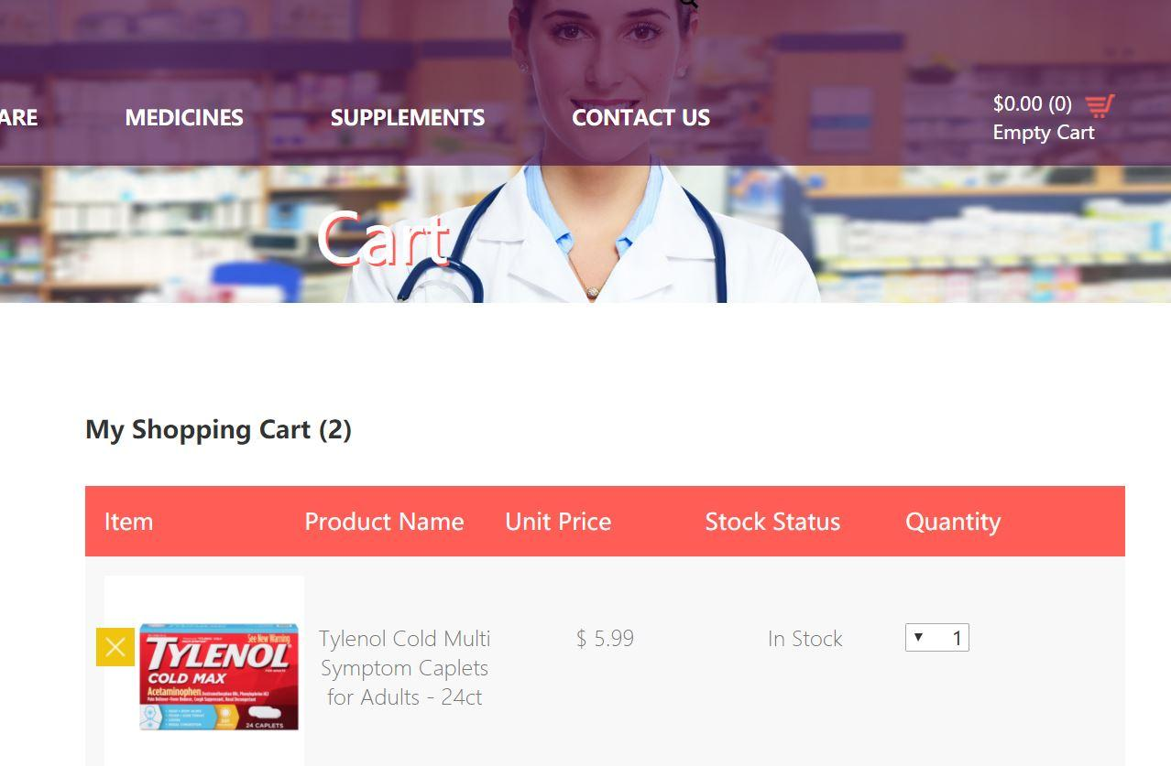

Picture 8:

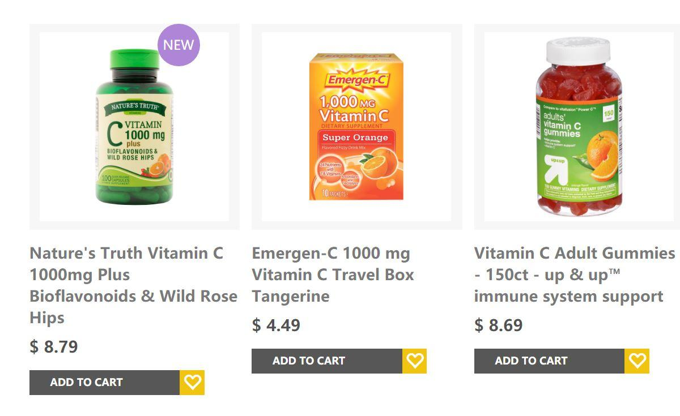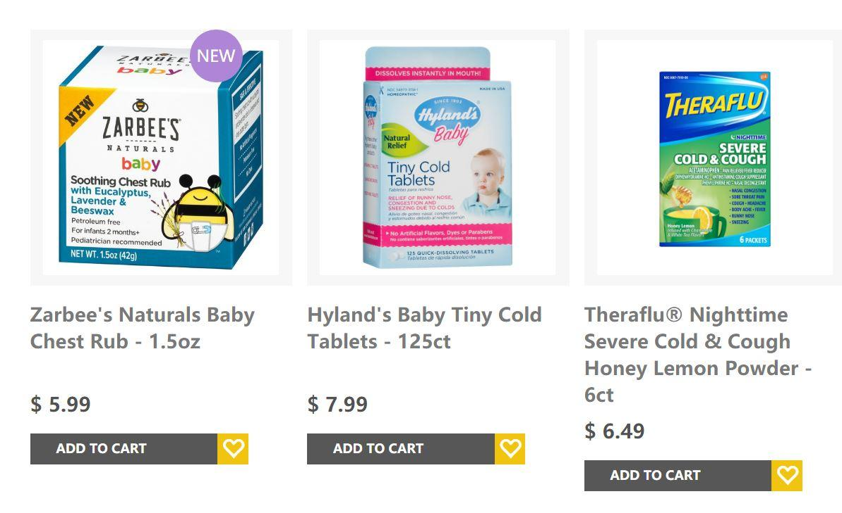

Picture 9:

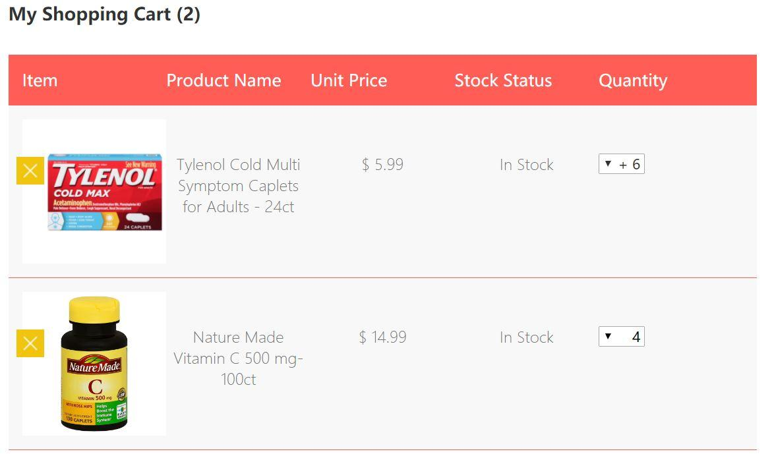

Picture 10:

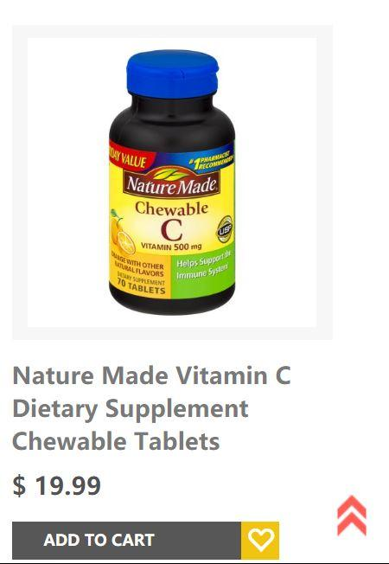

Picture 11:

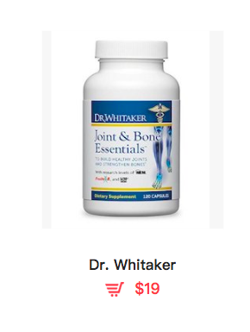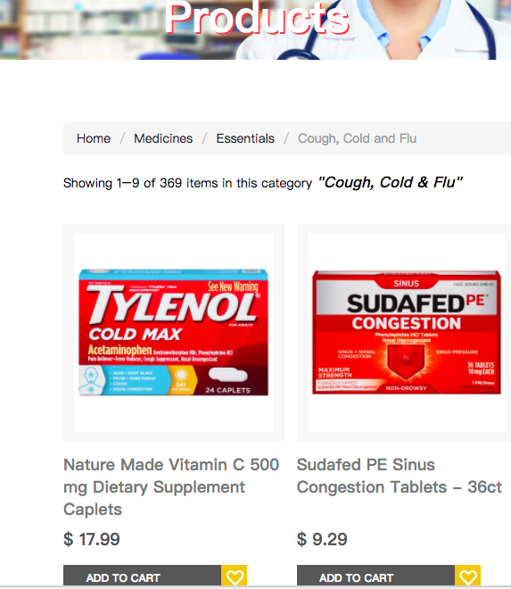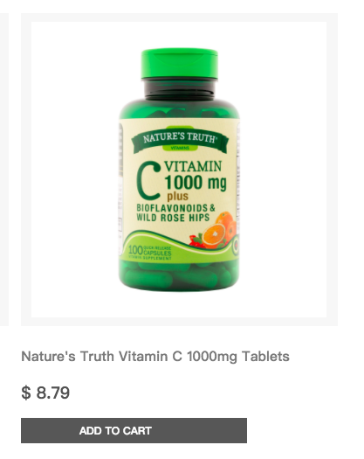

Picture 12:

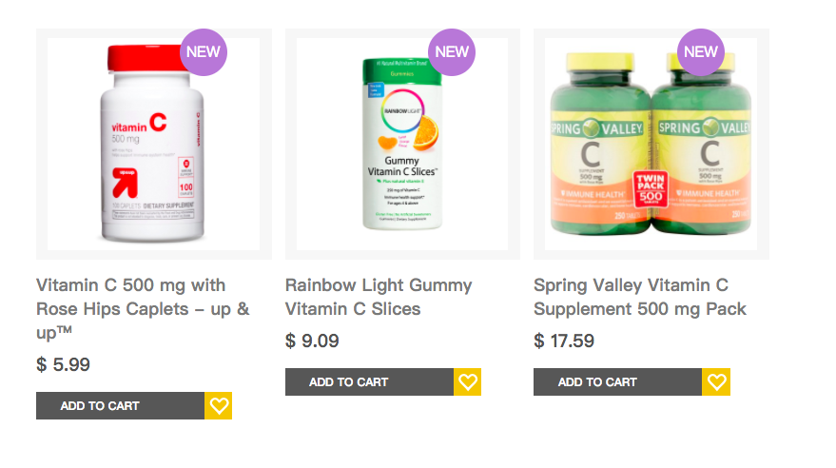

Picture 13:

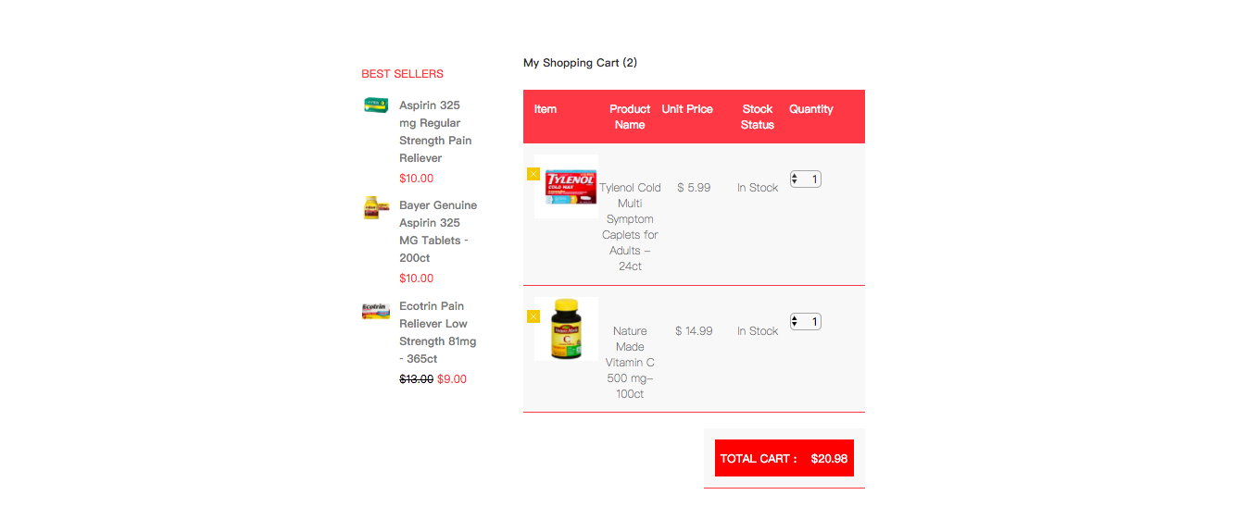

Picture 14:

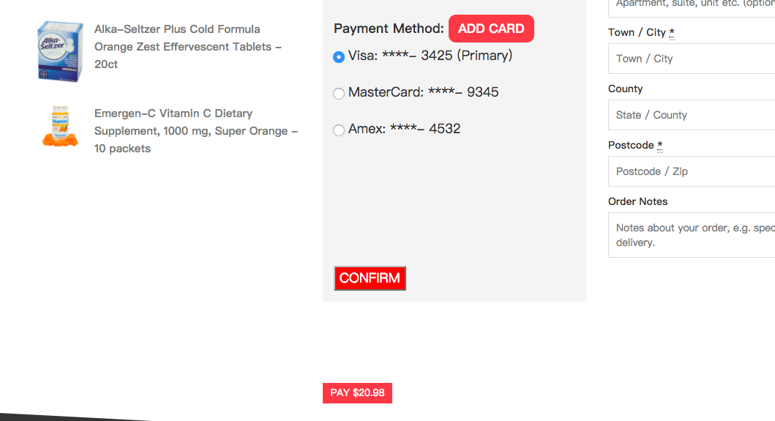

Picture 15:

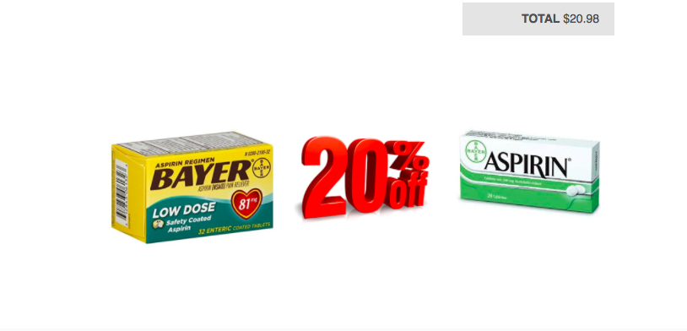

Picture 16:



Picture 17:

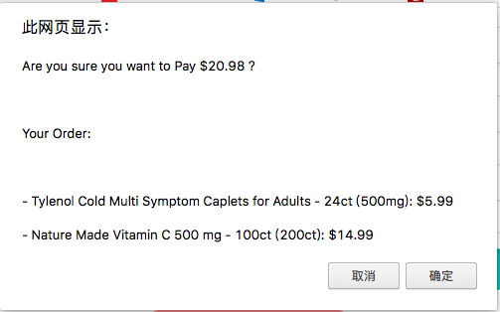

Picture 18:

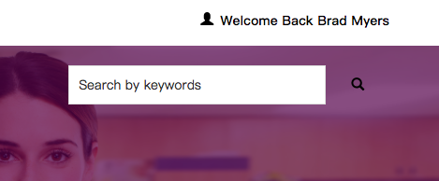

Picture 19:

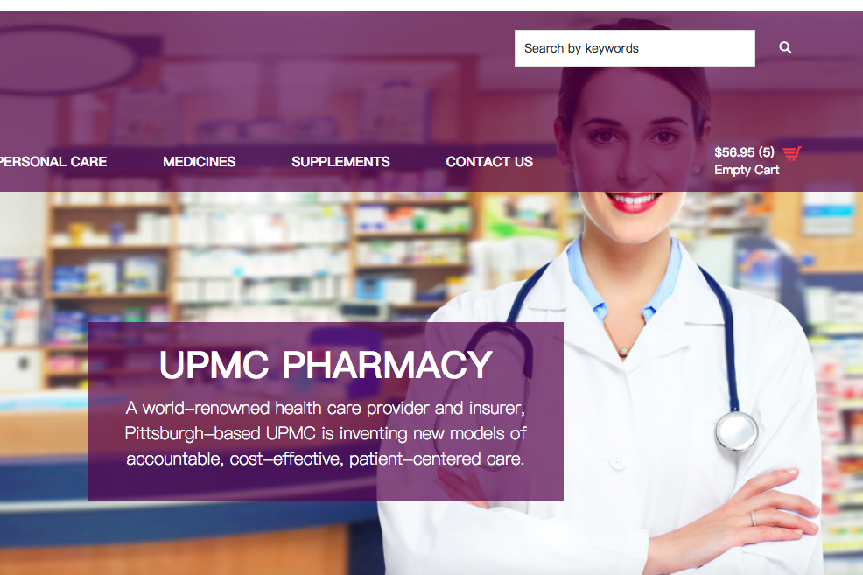

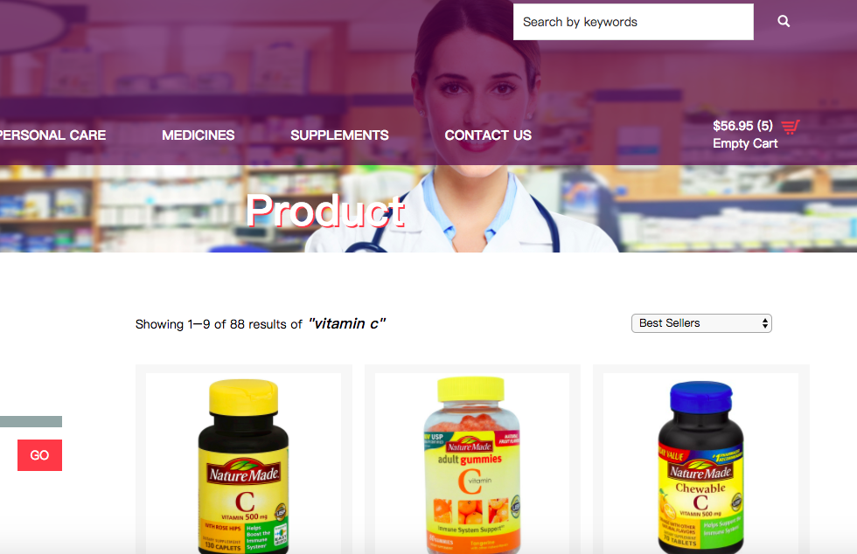

Picture 20:

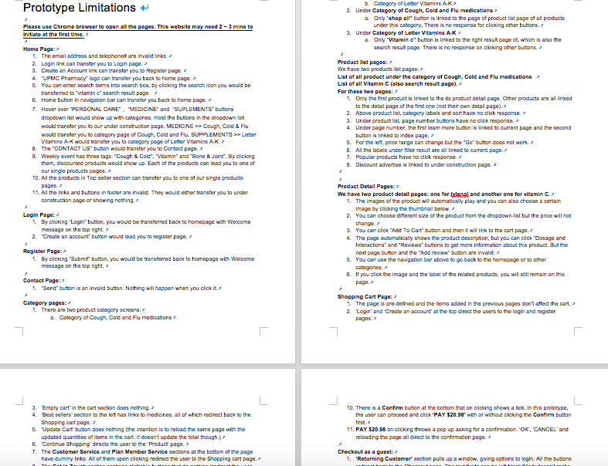

Picture 21:

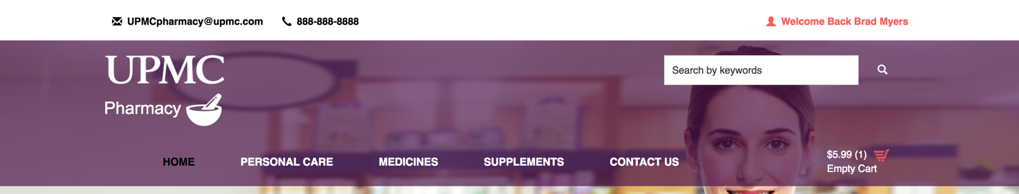

Picture 22:

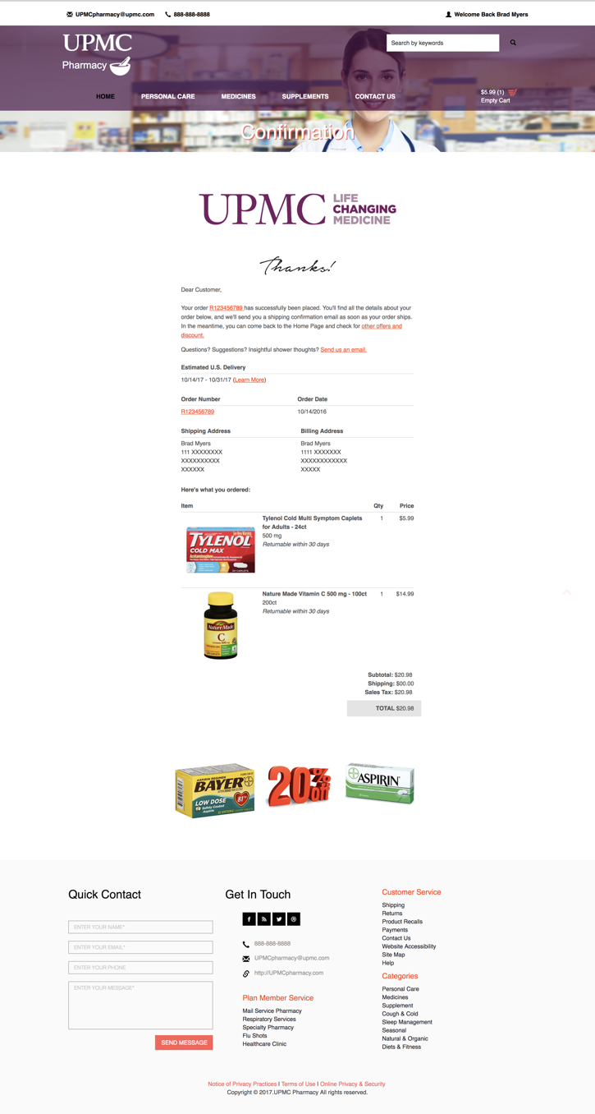

Picture 23:

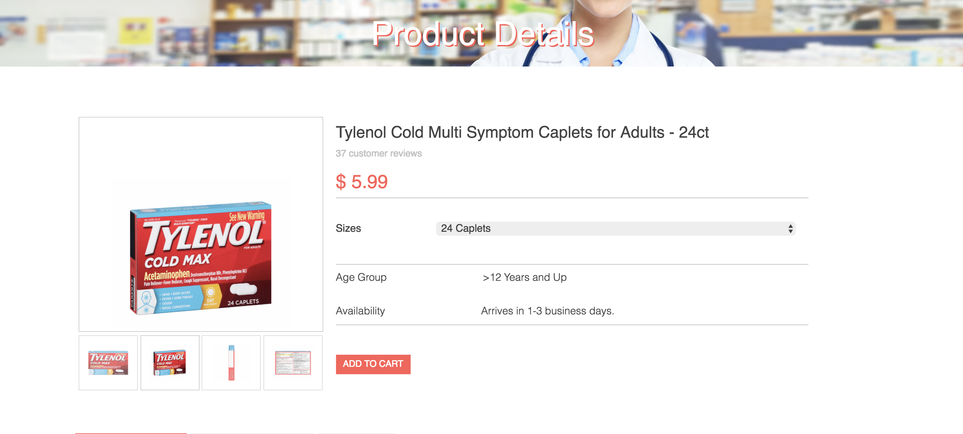

Picture 24:

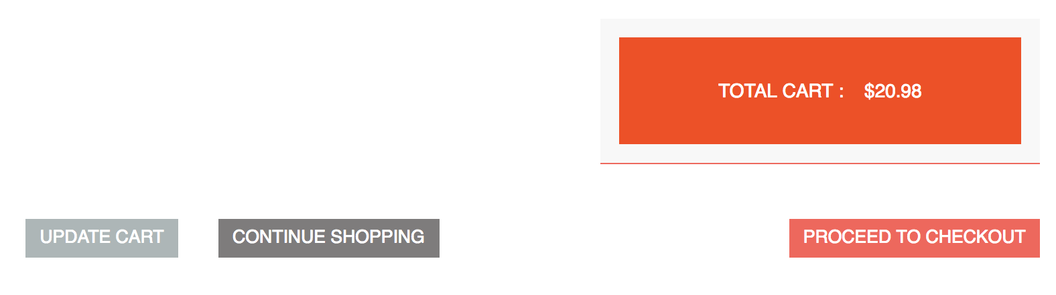

Picture 25:

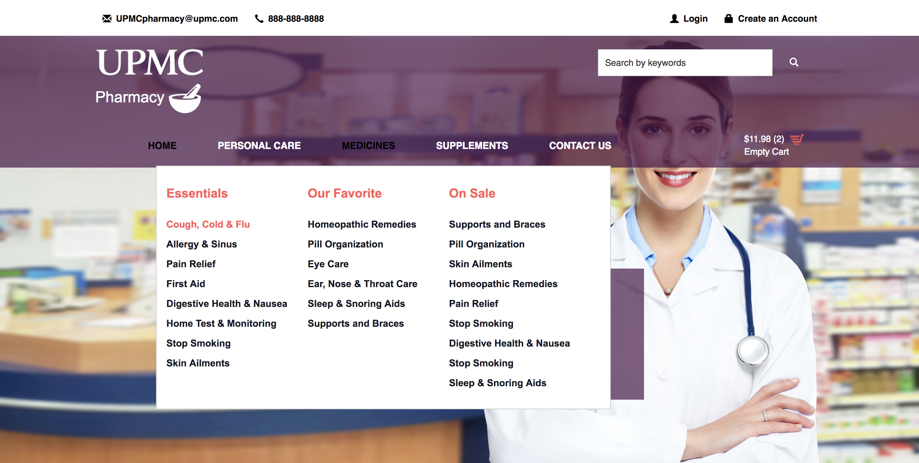

Picture 26:

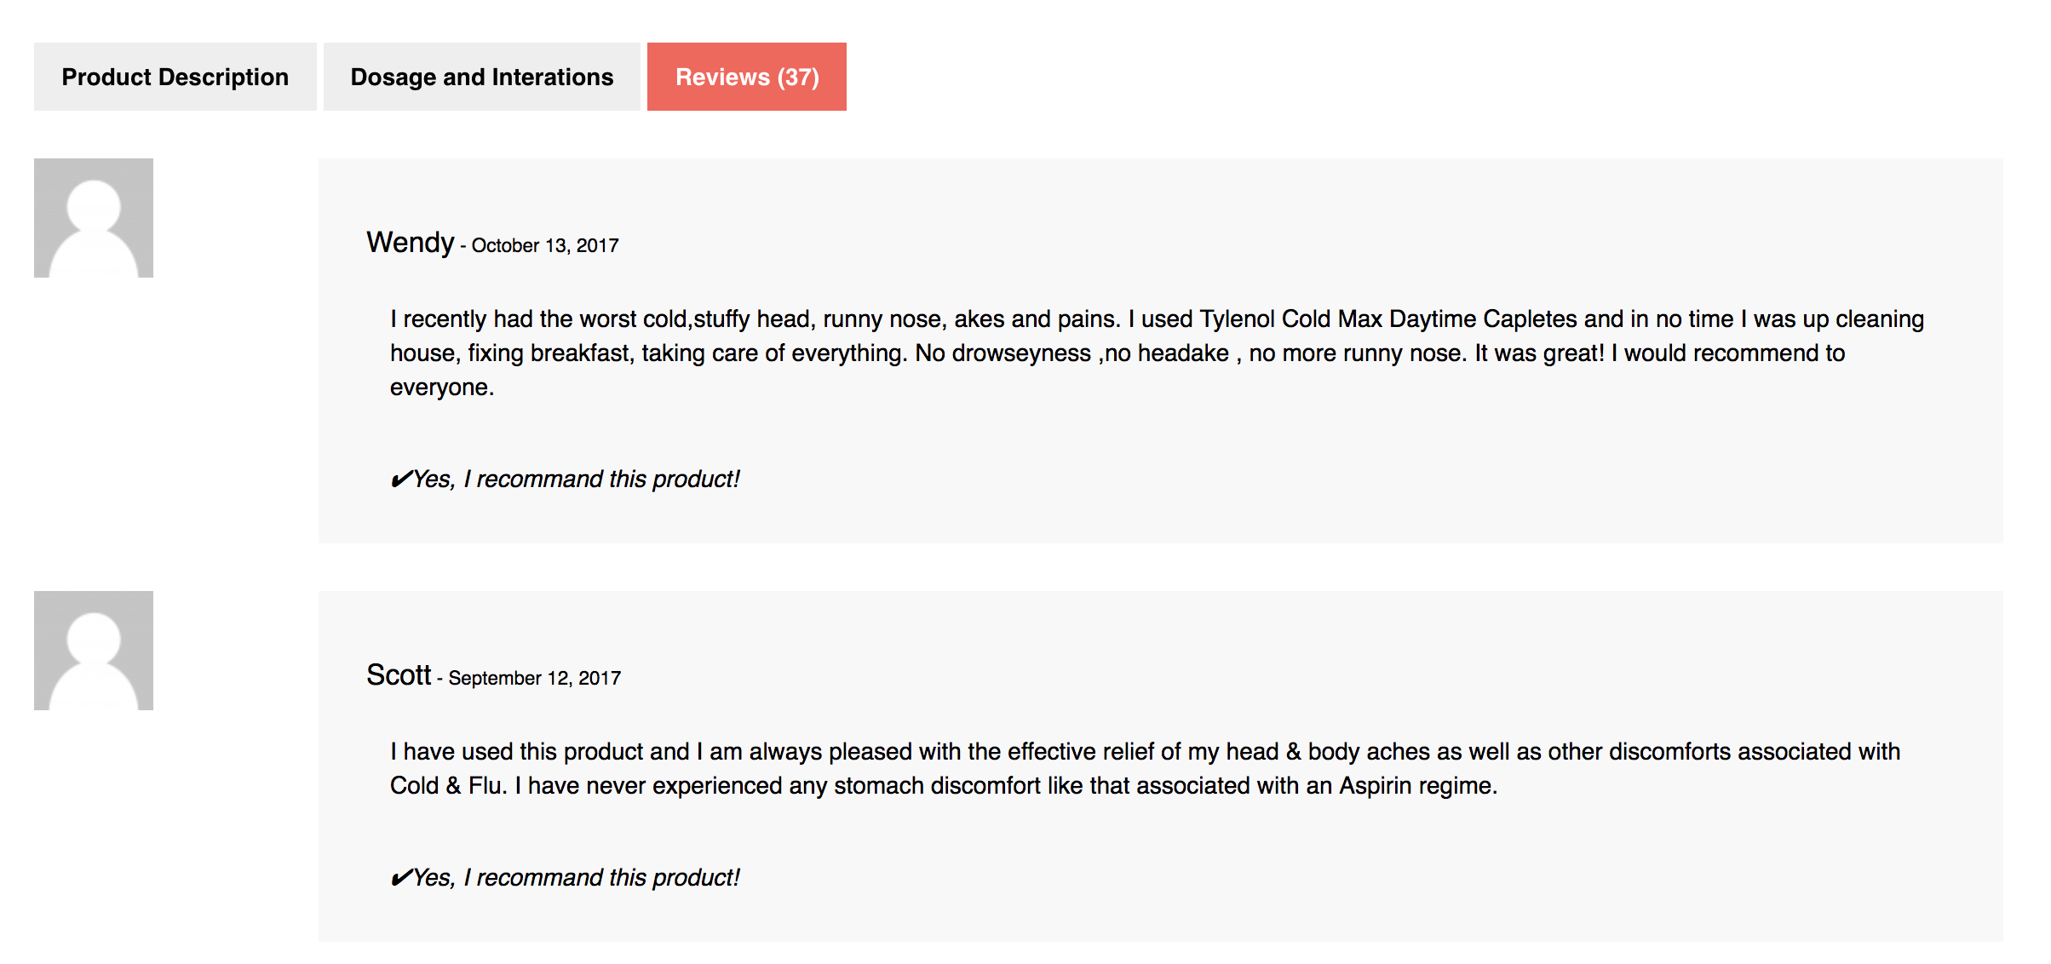

Picture 27:

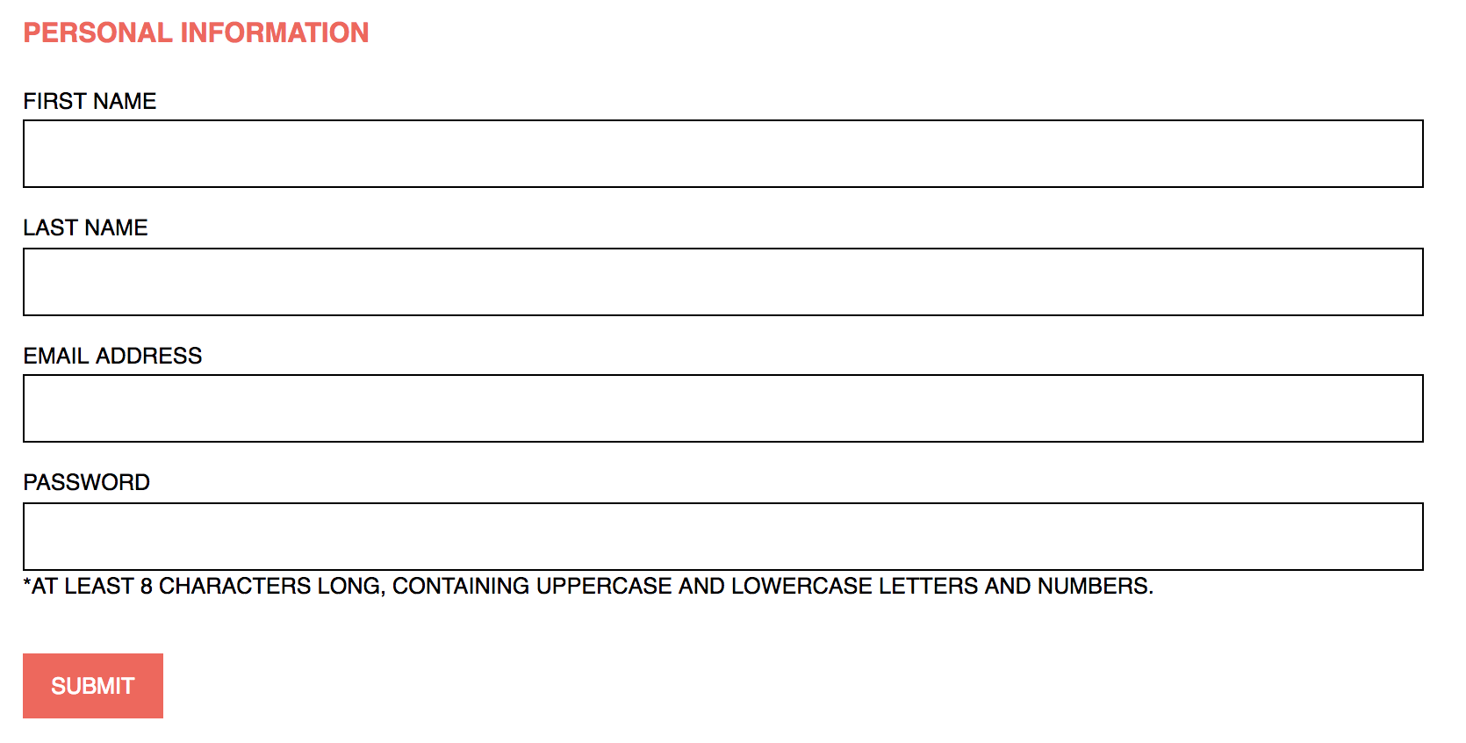

Picture 28:

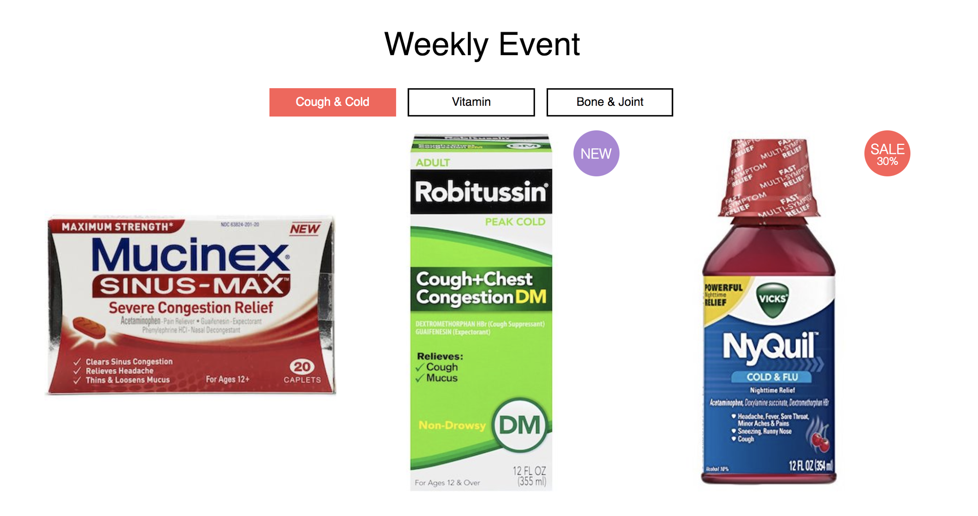

Picture 29:



Picture 30:

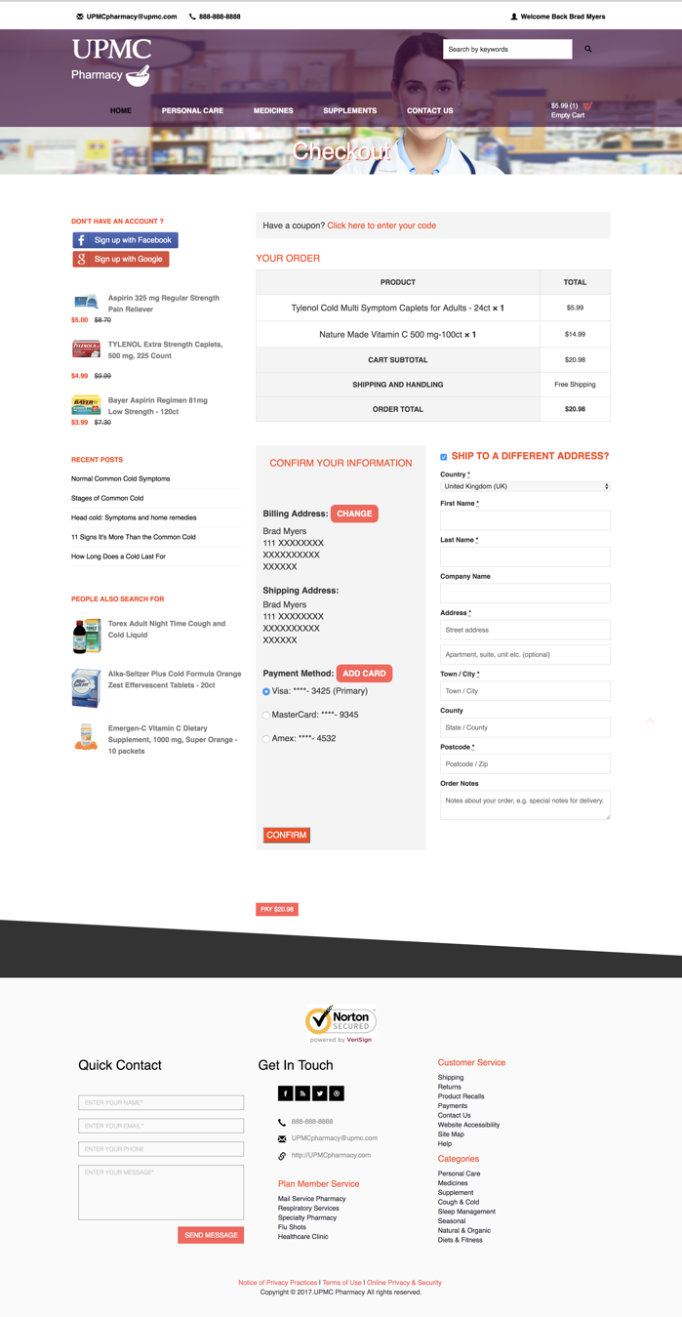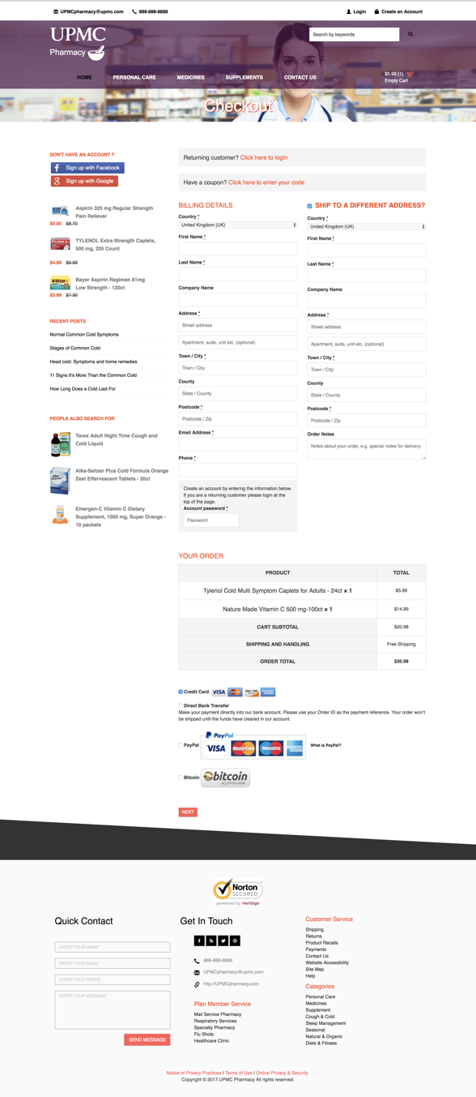

Picture 31:

<< insert picture 1 here >>



Picture 32:

<< insert picture 2 here >>

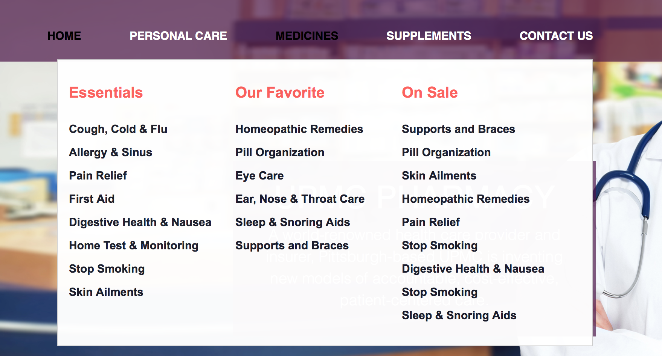

Picture 33:

<< insert picture 3 here >>

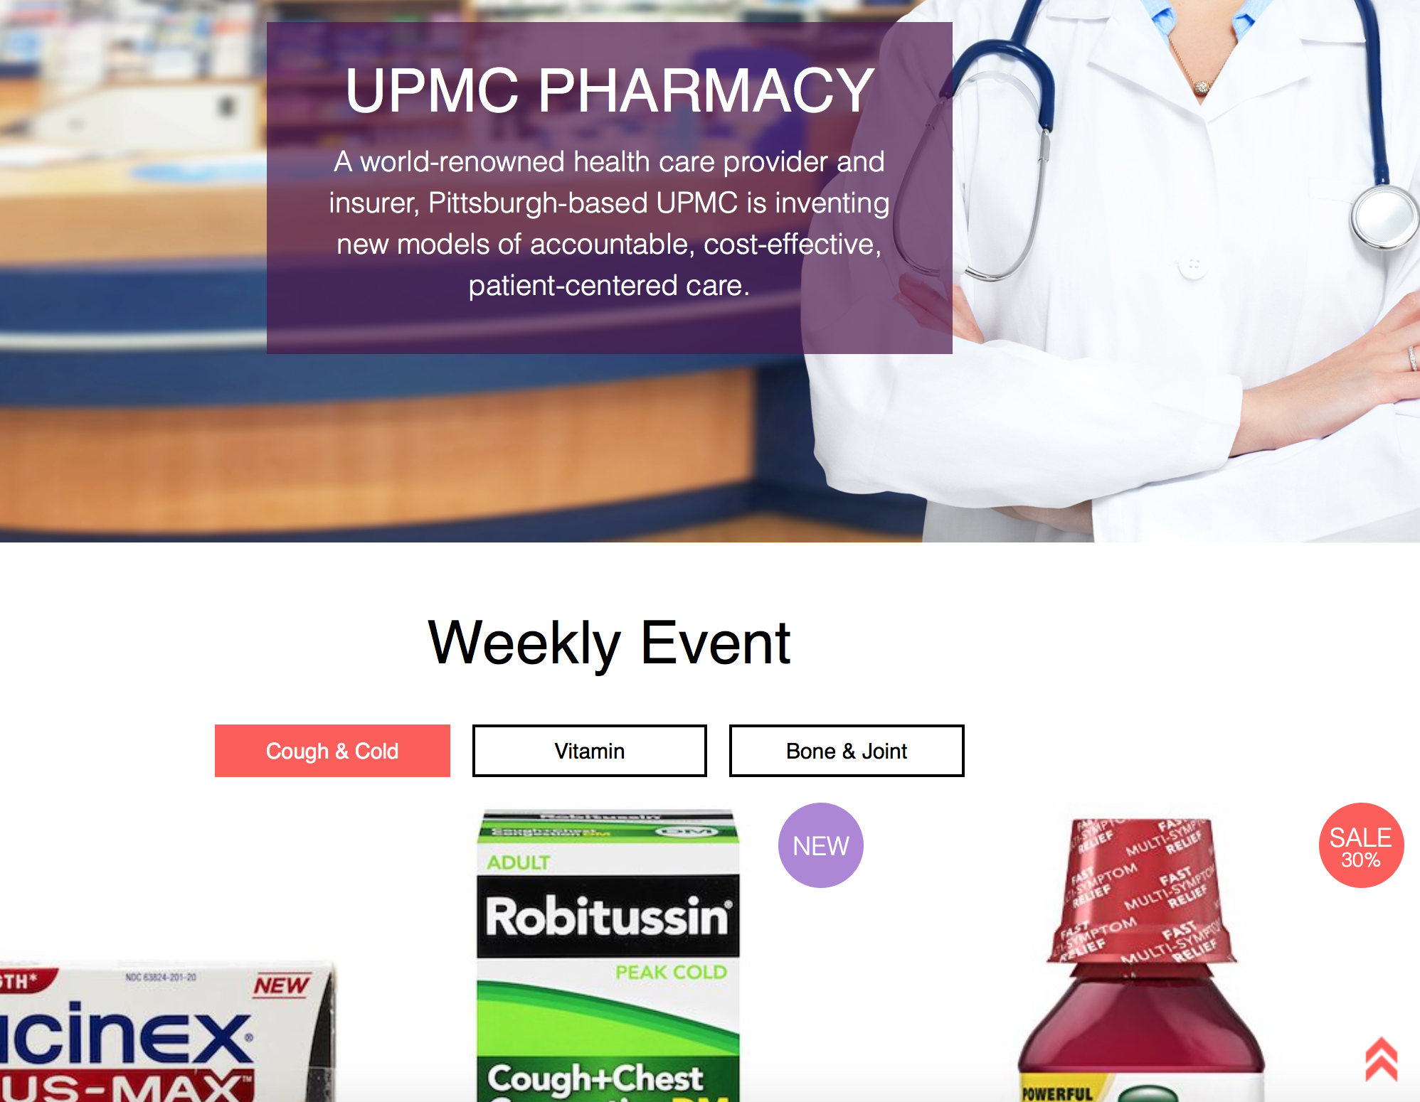

Picture 34:

<< insert picture 4 here >>

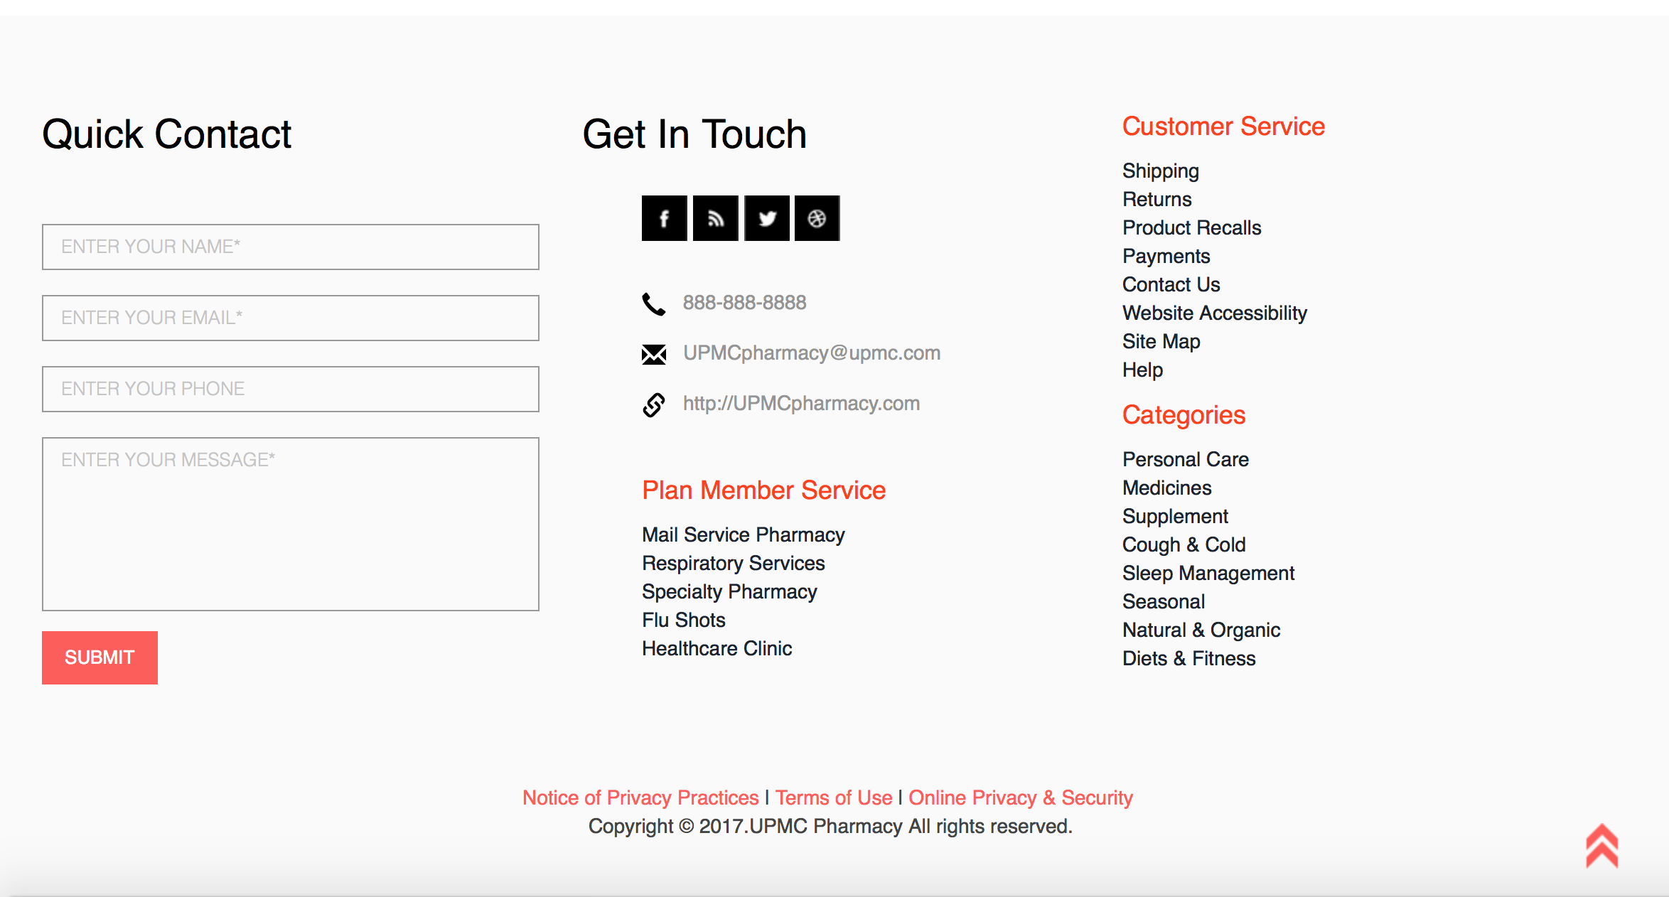

Picture 35:

<< insert picture 5 here >>

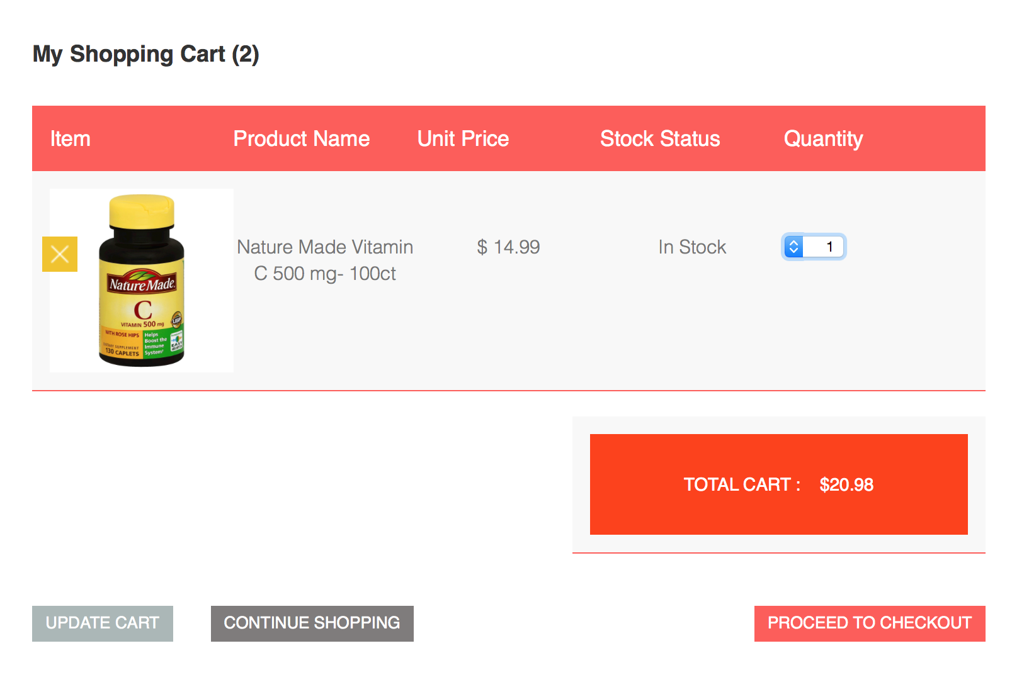

Picture 36:

<< insert picture 6 here >>

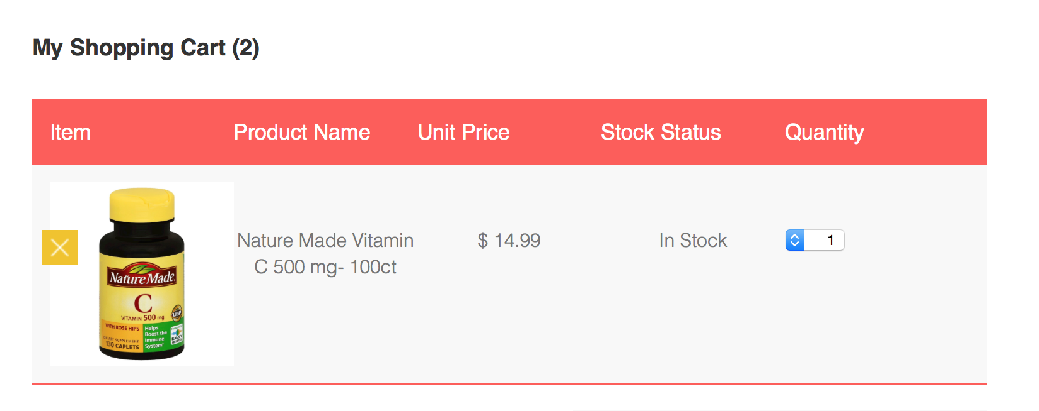

Picture 37:

<< insert picture 7 here >>

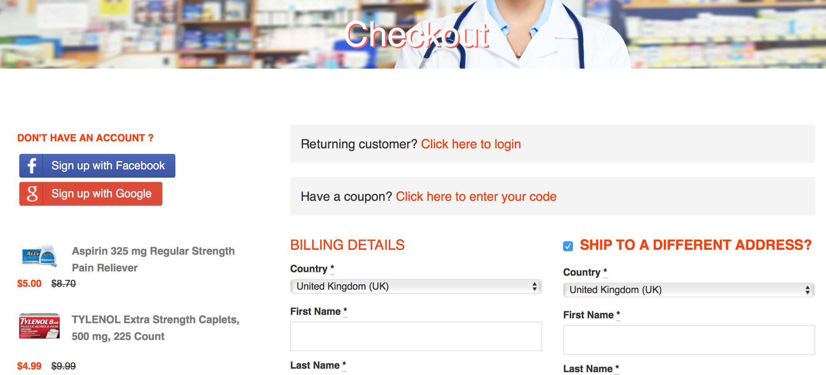

Picture 38:

<< insert picture 8 here >>

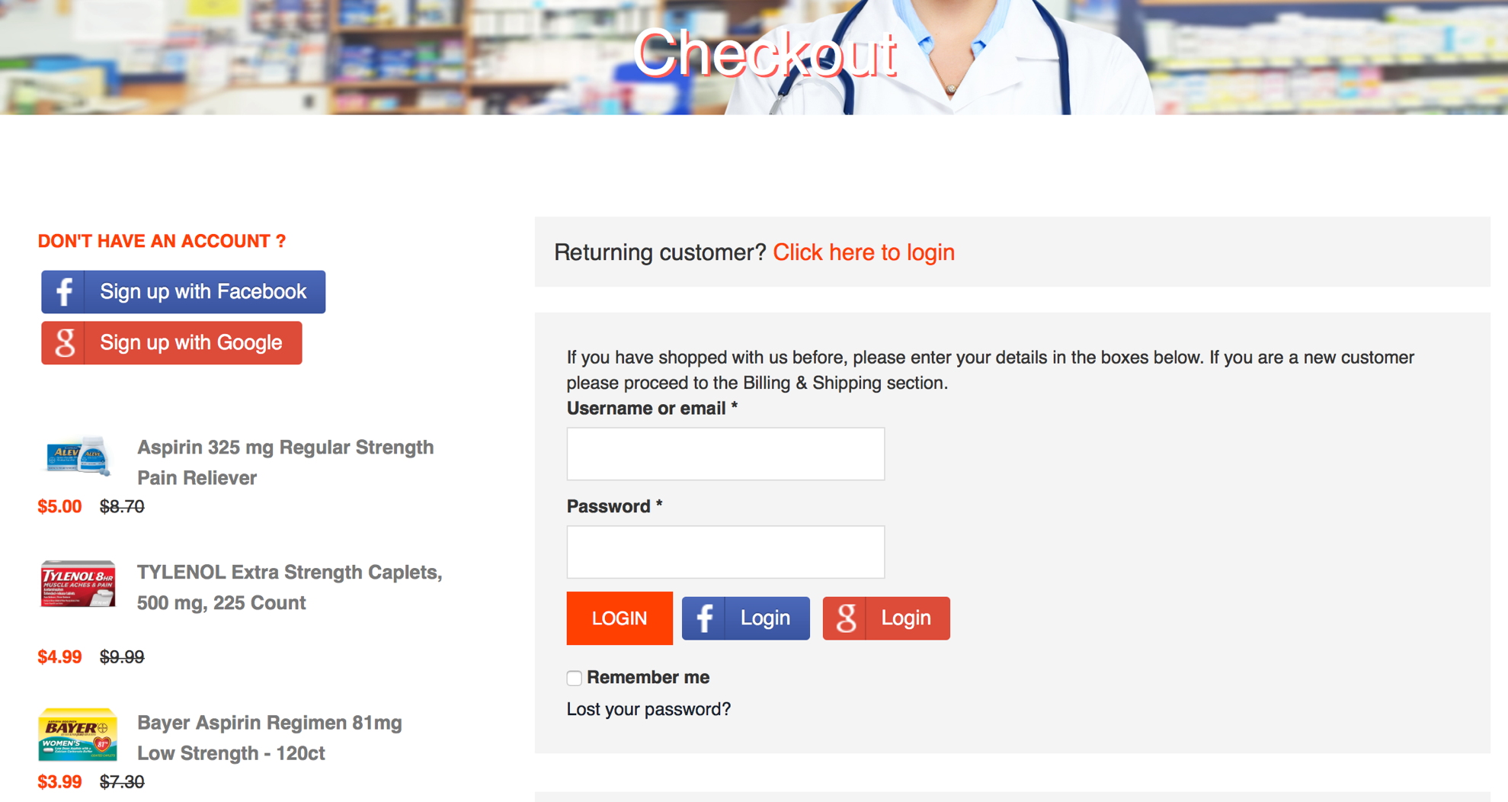

Picture 39:

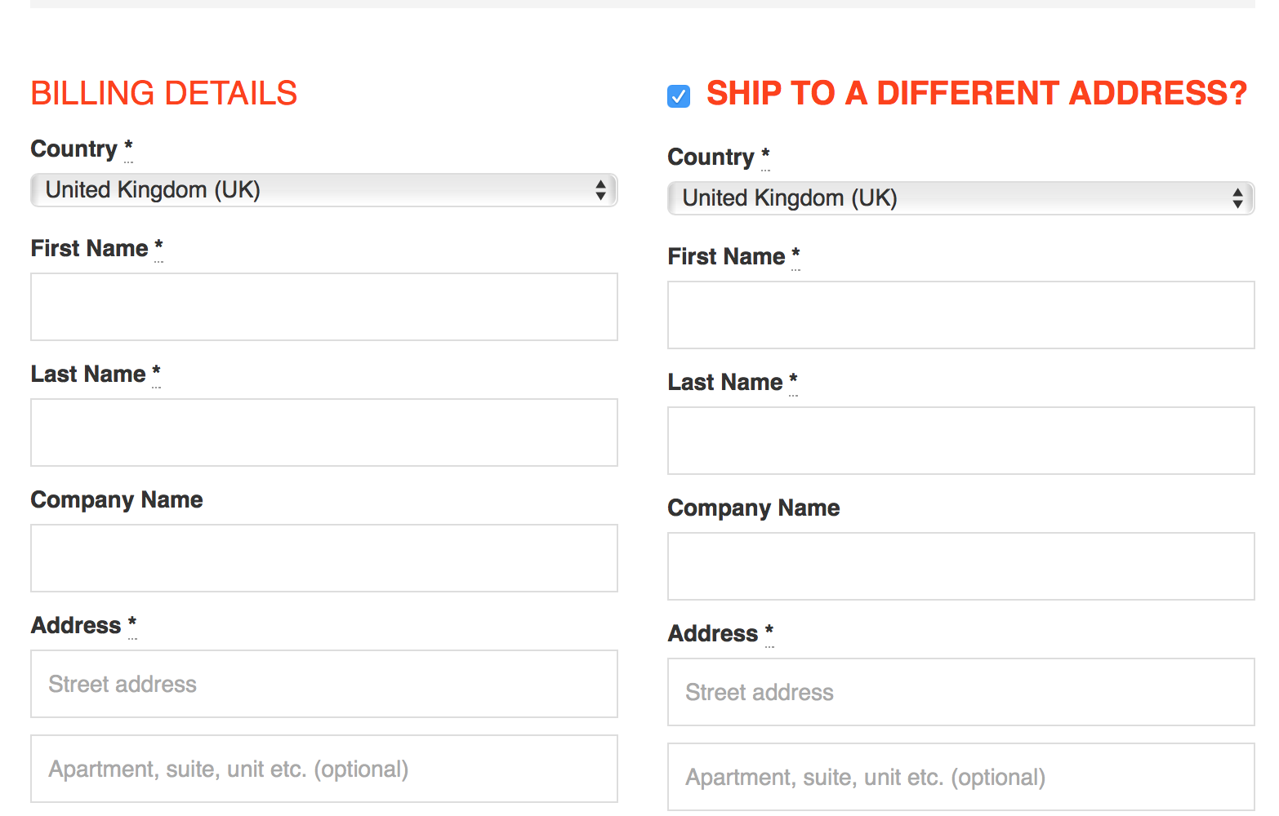

Picture 40:

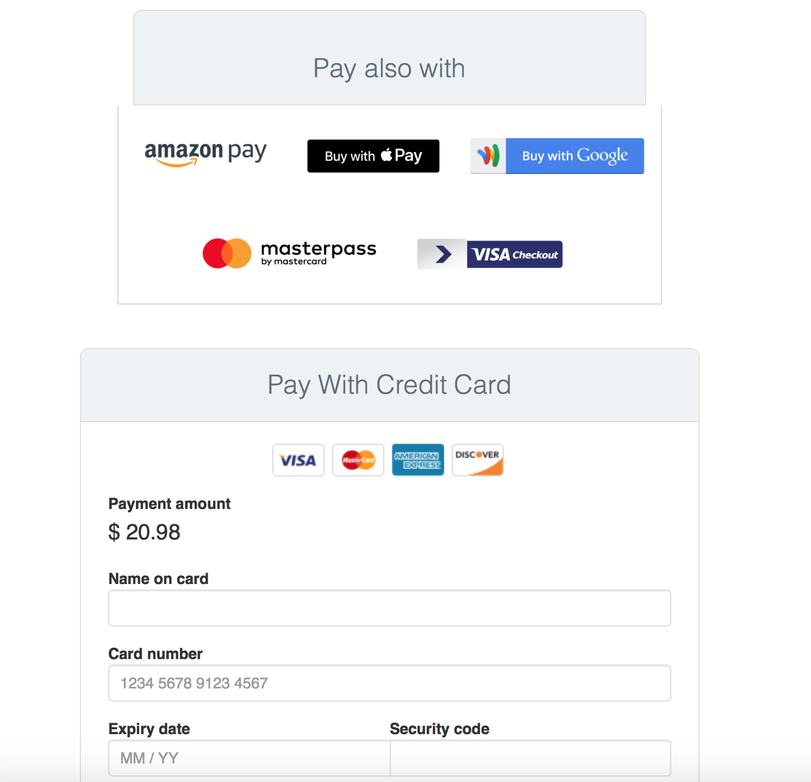

Picture 41:

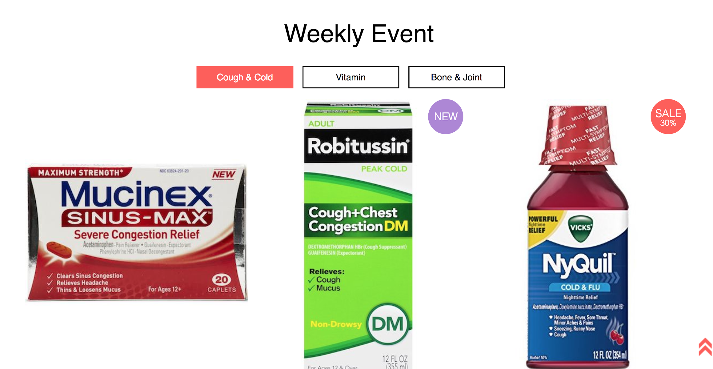

Picture 42:





Picture 43:

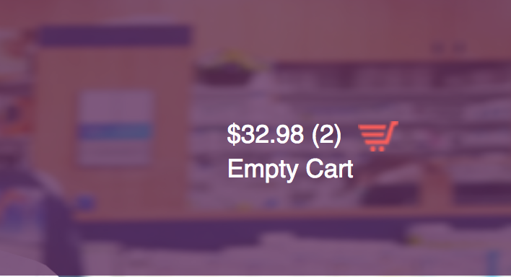

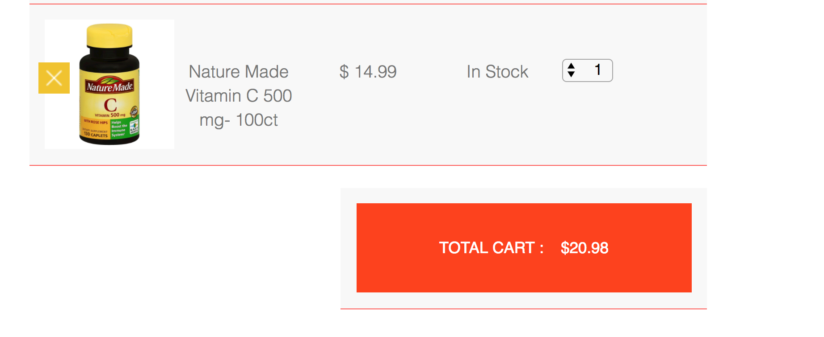

Picture 44:

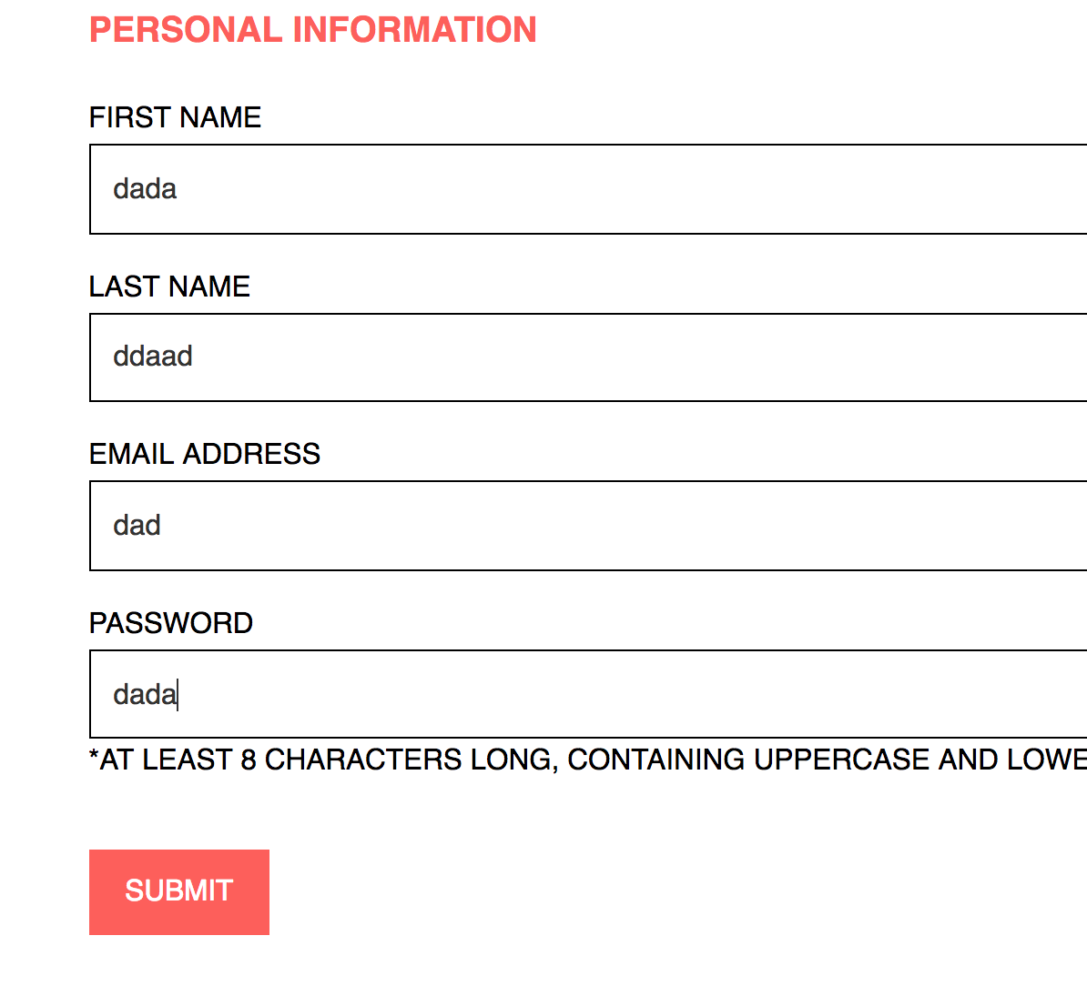

Picture 45:

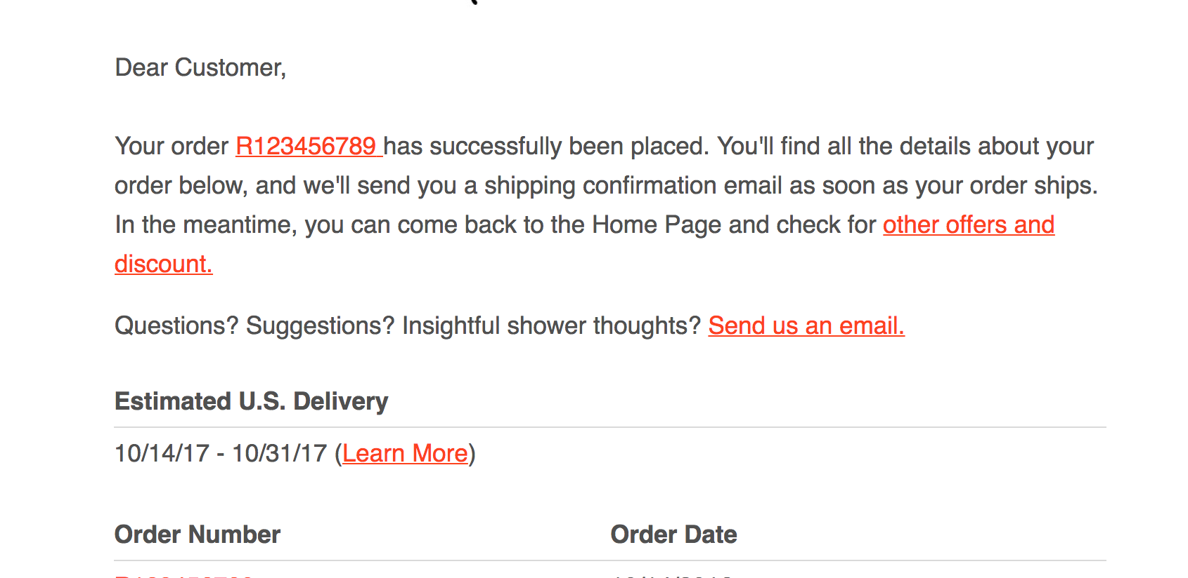

Picture 46:



Picture 47:



Picture 48:



Picture 49:

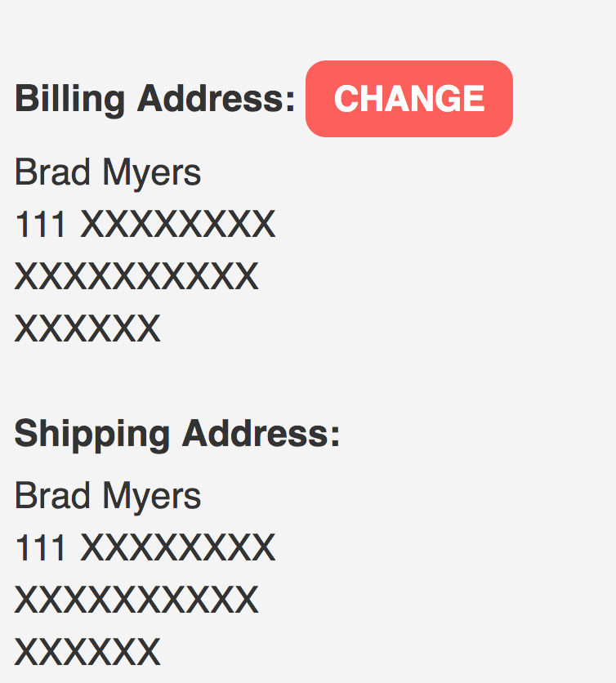

Picture 50:

